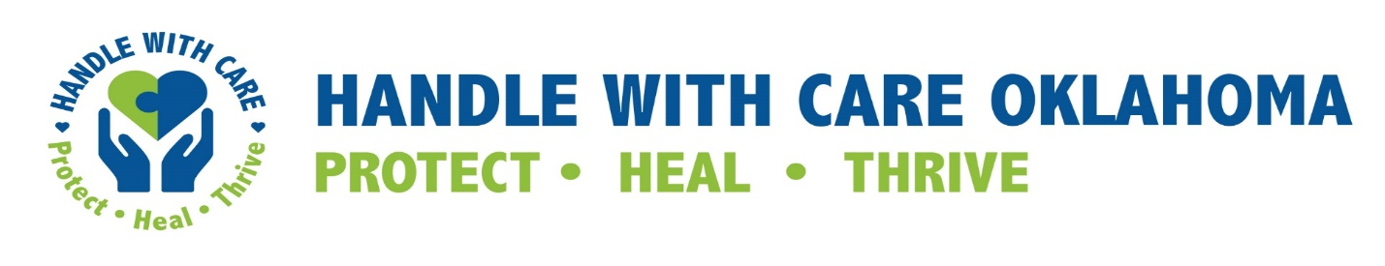
Memorandum of Understanding
Between
__________ School District
and
___________ Police Department, __________ County Sheriff’s Department,
__________Tribal Marshal, And/Or __________ State Police Department,

Notification of Exposure to Trauma

I. PURPOSE

The Larger Project. To further implement an initiative aimed at addressing children's exposure to violence and trauma. Childhood exposure to violence and trauma, without the right supports, is often associated with increased risk of poor outcomes in emotional, behavioral and physical health over the life span. Children exposed to violence and trauma are also at a higher risk of poor school related outcomes and are more likely to enter the criminal justice system later in life, which can contribute to generational cycles of violence and system involvement. This project directly addresses the goal of mitigating these negative impacts of exposure to trauma when it does occur, by providing support and on-site, trauma focused interventions by school staff and/or mental health providers, if necessary, to children identified by local law enforcement and school personnel.

Notification of Exposure to Trauma. Acknowledging the collaborative work already underway in the community around trauma and specifically around social and emotional health within the school system, this Memorandum of Understanding (“MOU”) will focus on notification to the school system by law enforcement when a child is exposed to trauma in the home or in the community to enable the child’s school to handle the child with care upon his or her arrival at school the next school day following the incident. For the purpose of this MOU, the phrase “exposed to trauma” shall be construed broadly and by way of example and not by way of limitation, shall mean and include any event where a child is a victim or witness, experiences or is involved in, or is questioned relative to, any of the following: the abuse of a family member, loved one, or pet; abuse or neglect; child custody, visitation or support or other domestic relations controversy where there is law enforcement intervention; community violence; the commission of a crime; loss of a family member or friend; an overdose; the arrest of a family member; racism or any other form of discrimination; homelessness; mental illness and /or substance abuse by a parent or caregiver; hospitalization or family illness; incarceration of a parent or family member; sudden, unexpected or frequent changes in caregiver, school, program or home life; natural disasters; or similar acts or experiences. Should a law enforcement officer be uncertain as to whether or not to give notice to the school, judgement should be exercised in favor of notification.

II. (_______________) Police Department, (_______________) County Sheriff’s Office, (_______________) State Police, (____________) Tribal Marshall (“LE”) Agree to:

- Send a notification to (_______________)School District identifying children that have been present for police interactions or otherwise exposed to violence or trauma in the community following the notification protocol as outlined below.
- Notification shall be given by sending an (method of sending: email, text, or dispatch) stating the child’s name, approximate age, school attended if known, the approximate time of the event, and the acronym HWC.
- Notifications will contain no specific information about the incident in order to maintain privacy of the student and their family.
- Otherwise maintain the confidentiality of students and their families.

III. (_______________) School District (“______”) agrees to:

- Receive notifications, as described in section II A and B above from LE and disseminate them to the designated point persons within each school by forwarding to them the HWC e-mail notification from LE.
- Upon receipt of a Handle with Care notification identifying a child who has been exposed to trauma, the designated point persons within each school will then disseminate the notification to appropriate teachers, social workers, guidance counselors, and any other relevant staff.
- Provide identified students who are exhibiting behaviors that are not consistent with their normal manner a safe person and space where they can receive additional supports, such as postponing a test, accepting a missed assignment, or allowing the student to rest if he or she is having a hard time focusing or staying awake, but otherwise not addressing the child about the incident.
- Determine need for on-going counseling (individual or group) or other interventions if the student is not currently involved with mental health/social services.
- If necessary, the school may contact parents or guardians to obtain appropriate consents for on-going mental health services for the student.
- Provide education on trauma informed care to all school personnel, parents and guardians, as requested and/or as required by law.
- Maintain the confidentiality of student's information, including but not limited to academic records, health records, and mental health services. Notifications may be maintained for any purposes consistent with the purpose of this MOU, but shall not be part of any student’s permanent record.

IV. TERMINATION, ADDITIONAL AGENCIES, AND LIABILITY:

- Any agency has the right to cancel this MOU with 30 days written notice to the other parties. Should any LE agency terminate this MOU, then the MOU shall remain in effect as to all other agencies.

- Additional agencies, whether or not a law enforcement agency, may become parties to this MOU with the agreement of “School”, which may be affected by the execution of an addendum to this MOU by such agency and “School”.

- Each party shall be responsible for the actions committed by that party and its agents. No party assumes any liability for any actions committed by any other party. However, each party to this Agreement agrees to cooperate fully with the other party in the defense of claims, pursuant to these provisions. This cooperation will include, but is not limited to, the following:
- Immediate notification to the other party of any accident or incident resulting in personal injury, damage or having the potential for liability;
- Immediate notification to the other party of any claim made against it alleging liability;
- Permit a party of this Agreement to conduct a parallel independent investigation of any incident, and/or
- Make personnel and records available for purposes of the investigation or defense of any claim and/or legal proceeding to the extent permitted by law.

This MOU shall remain in effect until terminated as provided herein.

Effective this _______ day of _________________ month of ______ year.

_______________________ POLICE DEPARTMENT

By: __________________________________________

____________________ SHERIFF’S DEPARTMENT

By: __________________________________________

_____________________________ STATE POLICE

By: __________________________________________

_________________________ TRIBAL MARSHAL

By: __________________________________________

__________________ COUNTY SCHOOL SYSTEM

By: __________________________________________

“HWC-MOU-between-School-and-Law-Enforcement with tribal rep”- updated 12.2022 Final Version

*Special thank you to Judge R. Michael Key, La Grange, Georgia for help in putting this MOU together and the Handle With Care OK Advisory Team for important updates based on local feedback. For questions or suggestions, please email info@handlewithcareok.org

